1. Select * from tblParents;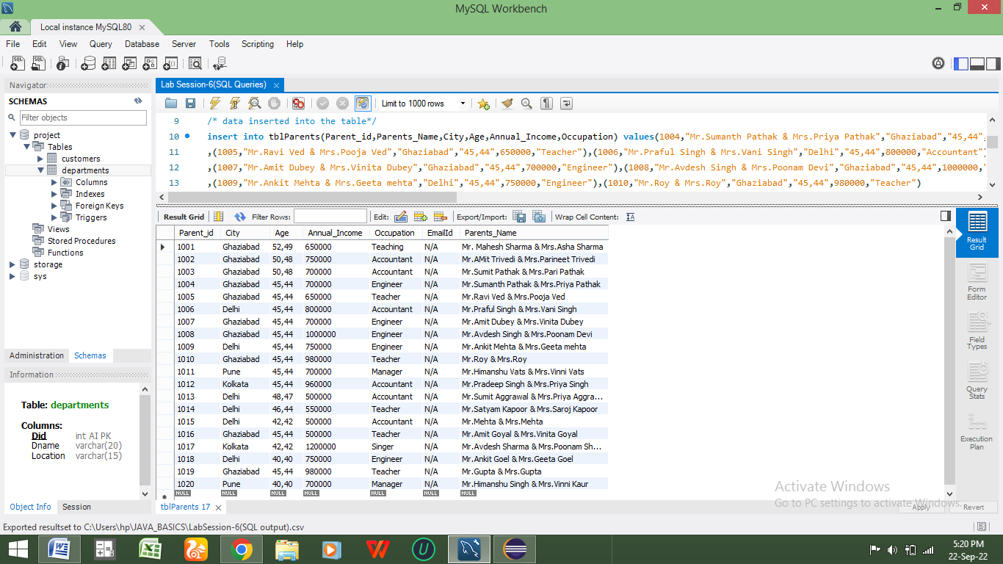
2. select count(Annual_Income) from tblParents where Annual_Income>600000;

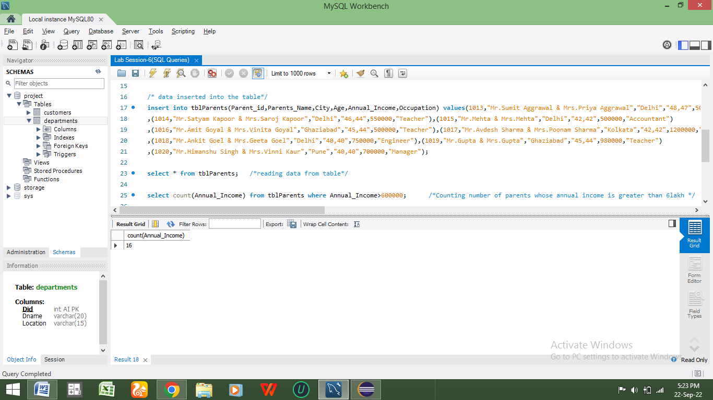

1. select count(Parent_id) from tblParents where Annual_Income<500000 or age>45;

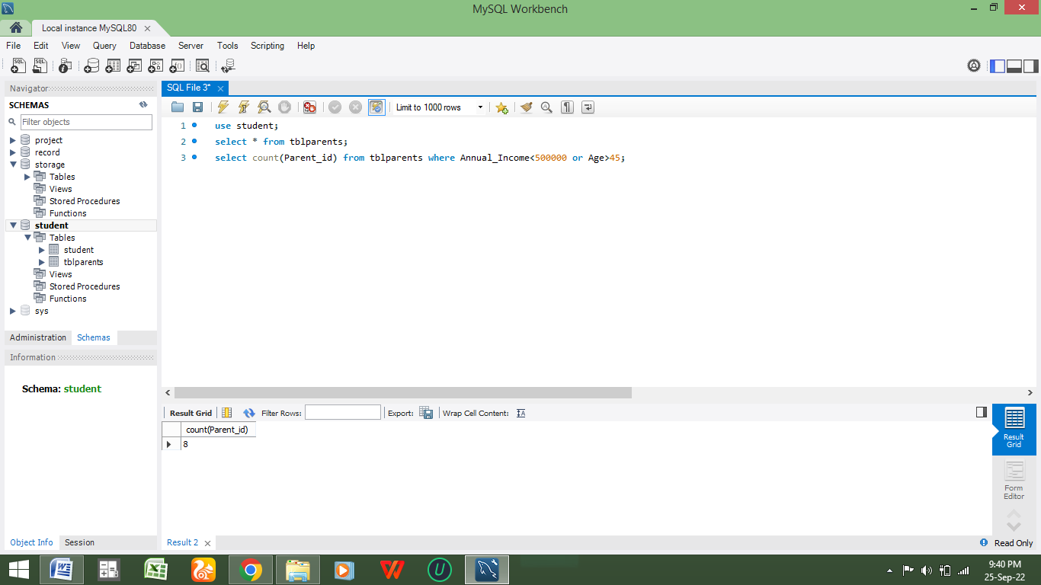

1. select * from Student;

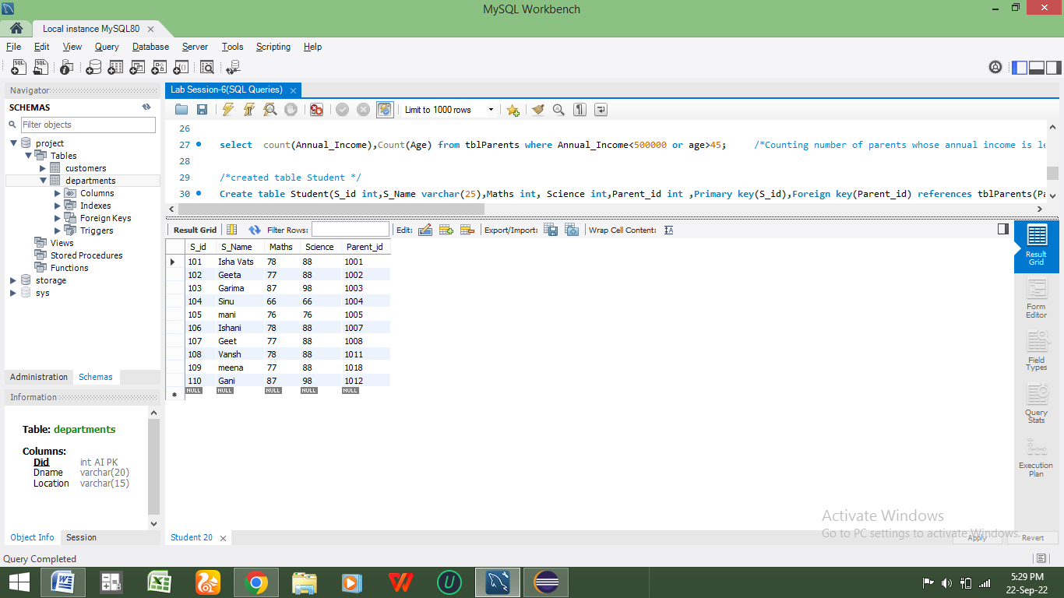

1. Update table tblParents set EmailId=’N/A’;

